|  |  |  |  |
| --- | --- | --- | --- |
| SPONSORSHIP Categories.  Opportunities for Sponsorship from new businesses are available for the 2021/22 Season  **$1000**   * Sponsorship of and Personal Advertising at a Major G.B.C Tournament * External, highly visible signage 800cm x 600cm * Internal sign above Bar in Gold Category * Multimedia Advertising Through Club House Monitor * Framed Certificate of Appreciation   **$500**   * Sponsorship of and Personal Advertising at a Major G.B.C Tournament * External, highly visible signage 550cm x 550cm * Internal sign above Bar in Silver Category * Multimedia Advertising Through Club House Monitor * Framed Certificate of Appreciation   **$250**   * Advertising at Internal G.B.C. Events * Internal sign above Bar in Bronze Category * Framed Certificate of Appreciation | **Signage Displayed Above Central B Green**  **GOLD**  **BRONZE**  **SILVER**  **GAWLER BOWLING CLUB SPONSORS**    **Beaumont Tiles Dr L Raggio & Dr D Priest Chiropractors**  **Ian & Jackie Goodrich Gawler Body Works**  **National Pharmacies Gawler Pest Control**  **Solomons Flooring & Sultan’s Blinds Goddard’s Fine Meats**  **Taylor& Forgie Funeral Directors Phil Hoffmann Travel**  **Rohde’s Free-Range Eggs**  **Tony Piccolo MP**  **Barker Real Estate**  **Barossa Valley Toyota**  **bloom hearing specialists**  **Cluse Bros Tyre Power**  **Elders Real Estate**  **Gawler Caravan Park**  **Gawler Dental Clinic**  **Gawler Community Retirement Homes**  **Have it Laid Tiling**  **Hillier Park Residential Village**  **JBG Architects**  **M & A Saliba Decorative Concrete**  **Millard Conveyancing**  **Mitre 10**  **Pauline Murray**  **Steinborner Hyundai & Mitsubishi**  **DONATIONS**  **Gawler Caddie Shack Subway Gawler**  **Kathryne Buckley Nancy Mitchell**  **K Bereton Jewellers Muriel Marsh: Memorial Championship**  **Kingsford Hotel Thorn Clarke Café Nova**  **BAR SIGNAGE** |  | **Current Sponsors**    Ian & Jackie Goodrich  Taylor & Forgie  Solomons Flooring& Sultan’s Blinds  National Pharmacies  Beaumont Tiles    Barker Real Estate  Barosssa Valley Toyota  bloom hearing specialists  Cluse Bros Tyre Power  Elders Real Estate  Gawler Caravan Park  Gawler Dental Clinic  Gawler Community Retirement Homes  Have it Laid Tiling  Hillier Park Residential Village  JBG Architects  M & A Saliba Decorative Concrete  Millard Conveyancing  Mitre 10  Pauline Murray Accountants  Steinborner Hyundai & Mitsubishi    Dr L Raggio & Dr D Priest Chiropractors  Gawler Body Works  Gawler Pest Control  Goddard’s Fine Meats  Phil Hoffmann Travel  Rohde’s Free-Range Eggs  Tony Piccolo MP    Taylor & Forgie  Solomons Flooring& Sultan’s Blinds    Barosssa Valley Toyota  Gawler Caravan Park  Gawler Dental Clinic  Hillier Park Residential Village  JBG Architects  Pauline Murray Accountants  Phil Hoffmann Travel  Mitre 10  Steinborner Hyundai & Mitsubishi    Barker Real Estate  Cluse Bros Tyre Power  Elders Real Estate  Gawler Body Works  Gawler Community Retirement Homes  Gawler Pest Control  National Pharmacies  Wintulichs  Goddard’s Fine Meats  Rohde’s Free-Range Eggs  Tony Piccolo MP |

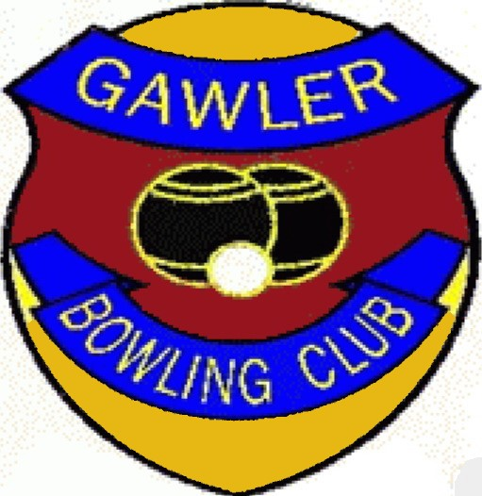**Victoria Tce Gawler SA 5118**

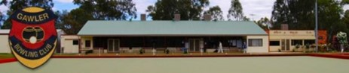 

We are a friendly, community-based Sporting and Social Club that welcomes new members and their friends.

Ph: (08)85221306

E Mail: [gawlerbowlingclub@iinet.net.au](mailto:gawlerbowlingclub@iinet.net.au)

[gawlerbc@iinet.net.au](mailto:gawlerbc@iinet.net.au)

Web Site: <https://gawlerbowlingclub.weebly.com>

Or “**Gawler Bowling Club**” in your browser.]

**CLUB** Contacts

**Board of Management**

**President: Kym Reynolds 0417847184**

**Vice President Men: Tim Hatcher**

**Vice President Women: Val Clark 0436470766**

**Secretary: Trevor Grant 0431924156**

**Treasurer: Shirley Branson 85223457**

**Board Members**

**Sandie Raggio Kay Moncrieff**

**Bob Wildy David Moncrieff**

**Sponsorship Coordinators**

**Phil Marsden 0498826965**

**Phil Parker 0409494702**



**OUR CLUB**

**We are a Sporting Club founded in 1907 that has a proud tradition of success**

**Current Membership is over 120.**

**The Club competes in the Metropolitan Bowl’s Association with Open Gender (Saturday), Female (Thursday) and Male (Wednesday) teams playing in Nominated Divisions.**

**We offer organised Social Competitions on Saturday and Wednesday all year round with Night Competitions on Tuesday and Wednesday at nominated times during the Pennant Season.**

**Our Greens are available to members all year round, 7 days a week, unless closed because of weather conditions.**

**Clubrooms and Facilities are available for Hire for Meetings (eg Probus Club) and Social Functions(eg Weddings, Birthdays, Group gatherings).**

**We have a strong presence in the Local Community reinforced through our Web site.**

**SPONSORSHIP INFORMATION**

**2021/22 Season**



* **Free Coaching**
* **Use of Club Bowls**
* **Excellent Facilities**
* **Social and Friendly Atmosphere**

**Social Bowls**

Saturday & Wednesday All year Round

12:00 - 12:30 Registration Non-Pennant Season (Winter)

9:30 – 10:00 Registration During Pennant Season (Summer)

Summer Tuesday and Wednesday Social Night Bowls as Programmed

**Pennants**

Wednesday – Men

Thursday – Ladies

Saturday – Open Gender.